A000-Afr-Nigeria-Igbo-Agbogho Mmwo-Igbo Maiden Masks-early 20th c

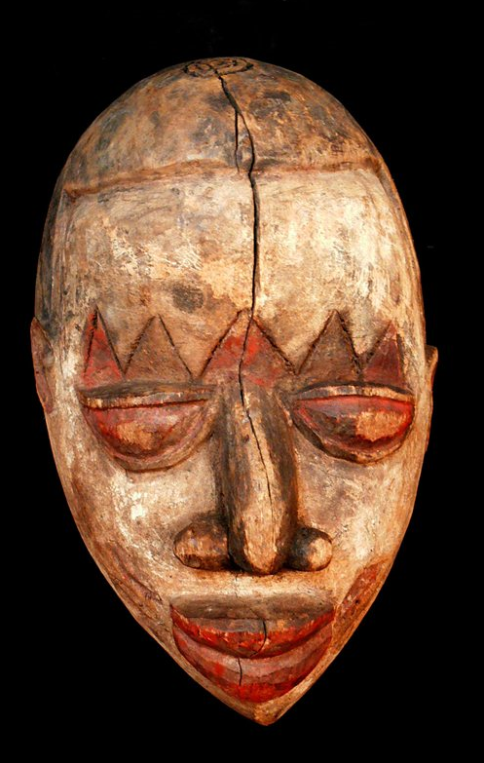 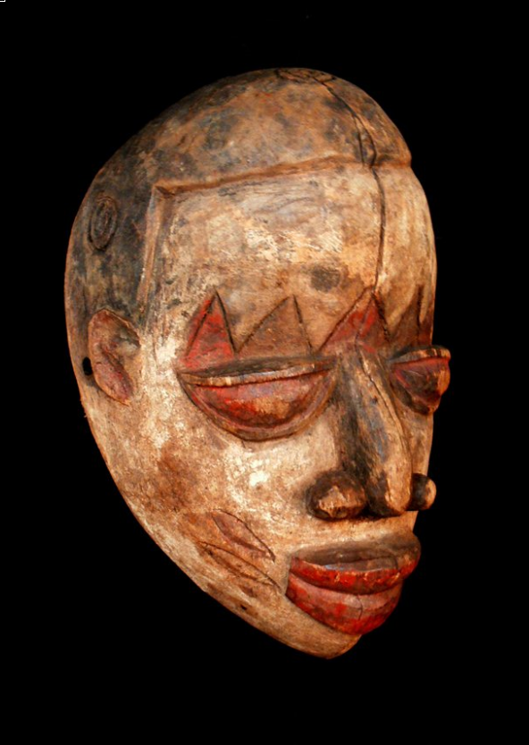 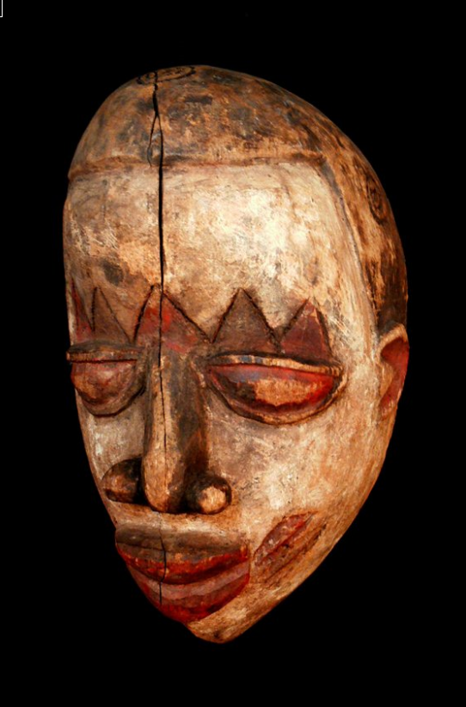 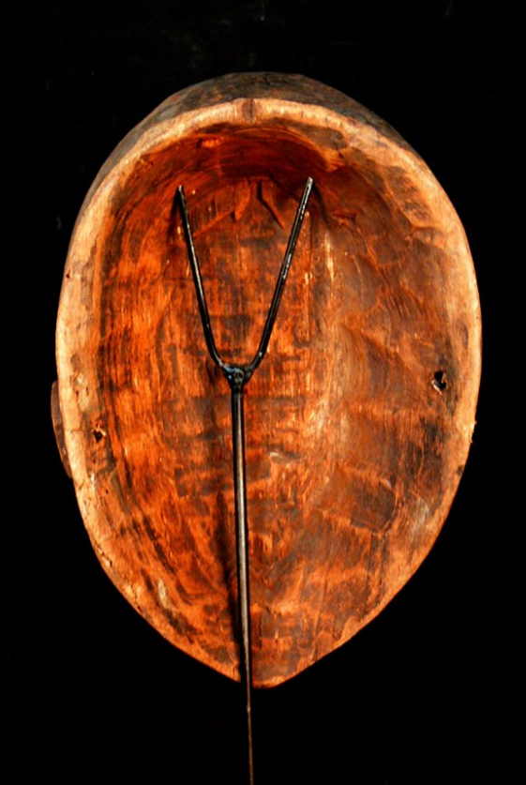

Case No.: 6

Case No.: 6

**Accession No.**

**Formal Label:**

**Display Description:**  
 Every Igbo town differs in terms of its range of festivals and types of masks, and oftentimes the spiritual and stylistic forms intermingle between regions,  making it difficult to trace this mask to one particular location. However, masking traditions throughout the various Igbo regions share underlying themes  and similar spirits, and so the purpose of this maiden mask can be at least somewhat clarified. Of the two most important mask types among the Igbo--  those idealizing the qualities of young women, and those representing the powers of men, the maiden mask embodies the former. When the mask is  worn, always by a man, the maiden spirit a dancer personifies represents the ideals of youthful feminine grace and beauty, albeit exaggerated both in   
the masks and the performance of them.  
  
  
 Igbo models of beauty are based on both physical and moral dimensions. Physically a girl should be tall and slender, with a long neck, full and pointed  breasts, light complexion and small features, her hair elaborately dressed (preferably in the crested style) and her features brought out by facial tattoos.  These observable qualities mirror the spiritual traits desired by Igbo males - purity, as defined by the paleness of her complexion, grace in the form of  her facial features and the manner in which the spirit is danced, obedience, good character, and generosity. In addition, the crested hairstyle, which is  often considered a sign of wealth or royalty, is a symbol of the young Igbo maiden as the source of bride-wealth for her family upon her marriage. Such  physical and moral ideals are often not matched in reality, and are not necessarily meant to the maiden spirits are transcendent, a connection between  Igbo desires of beauty and the spiritual awesomeness of the incarnate dead.  
  
Maiden mask artists favored red, orange, yellow, and black pigments to highlight their carvings, along with other colors, and these can be seen on the  entirety of the mask. As in a number of the more elaborate masks, which can have anywhere from one to three hair crests, this maiden has three crests   
dramatically pairing positive and negative space.  
  
 Maiden masks are used mostly during agricultural festivals (usually the dry season) and the second funerals of prominent society members. On latter  occasions maiden spirits are invoked alongside other spirits as appropriate escorts of the highly respected dead into the spirit world. During agricultural  or other ceremonies, however, maiden spirits appear to aid in watching over the living and to promote abundant harvests, fertility, and general  prosperity. Maiden spirits are light-hearted in contrast to more menacing spirits of the Igbo world, which often generate a more serious atmosphere.  Maiden maskers perform almost theatrically, as if in a play, their purpose to entertain both human and spirit audiences.

SOURCE:  
Aniakor, Chike C. and Herbert M. Cole. Igbo Arts: Community and Cosmos. Museum of Cultural History, University of California: Los Angeles, 1984.

**LC Classification:**

**or Time Horizon: early 20th c**

**Geographical Area:**

**Map:**

**GPS coordinates:**

**Cultural Affiliation:**

**Media: wood, polychrome pigments, kaolin**

**Dimensions:** 12.204 inches

**Weight:** 1.25 pounds

**Condition:**

**Provenance:**

**Discussion:**



|  |
| --- |
| Igbo maiden-spirit maskers near Akwa, Nigeria 1935  "The white maiden masks, all danced by men, have super structures of several  types, indicating spirit characters of different ages. The eldest daughter, called  Headload because of her mask's large figured superstructure, leads the others. Her  younger sisters, following, have elaborate crested hairstyles and small pointed  breasts. All wear bright polychrome appliqué cloth "body suits" whose patterning  loosely resemble monochromatic designs painted on youthful females in the area.  Other characters in the drama are a mother, a father, sometimes an irresponsible  son, and a suitor costumed as a titled elder, whose amorous, often bawdy advances  to one or more "girls" are invariably rebuffed. The play unfolds predictably, with the  maidens' dances becoming ever faster and more virtuosic as the maskers compete  with one another for audience approval and even financial reward."  Source: A History of Art in Africa |

**References:**